**DAILY ONLINE ACTIVITIES SUMMARY**

|  |  |  |  |  |  |  |  |  |
| --- | --- | --- | --- | --- | --- | --- | --- | --- |
| **Date:** | **9-06-2020** | | | | | **Name:** | **Kavya** | |
| **Sem & Sec** | **6th & A** | | | | | **USN:** | **4AL17CS041** | |
| **Online Test Summary** | | | | | | | | |
| **Subject** | | **COMPUTER GRAPHICS** | | | | | | |
| **Max. Marks** | | **30** | | **Score** | | | **27** | |
| **Certification Course Summary** | | | | | | | | |
| **Course** | **Maths for Data science** | | | | | | | |
| **Certificate Provider** | | | **Udemy** | | **Duration** | | | **2.5 Hours** |
| **Coding Challenges** | | | | | | | | |
| **Problem Statement:1.**  Write a C Program to rotate the matrix by K times.  2. Write a Python to implement Perfect Sum Problem.  3. Write a Java Program to print smallest and biggest possible palindrome word in a given string  4. Python Program to count even and odd numbers  5. Write a Java Program to remove all white spaces from a string without using replace() | | | | | | | | |
| **Status:Yes,I have uploaded all the programs.** | | | | | | | | |
| **Uploaded the report in Github** | | | | | **Yes** | | | |
| **If yes Repository name** | | | | | [**https://github.com/kavya-077/DAILY-STATUS**](https://github.com/kavya-077/DAILY-STATUS) | | | |
| **Uploaded the report in slack** | | | | | **Yes** | | | |

Online Test Details: (Attach the snapshot and briefly write the report for the same)

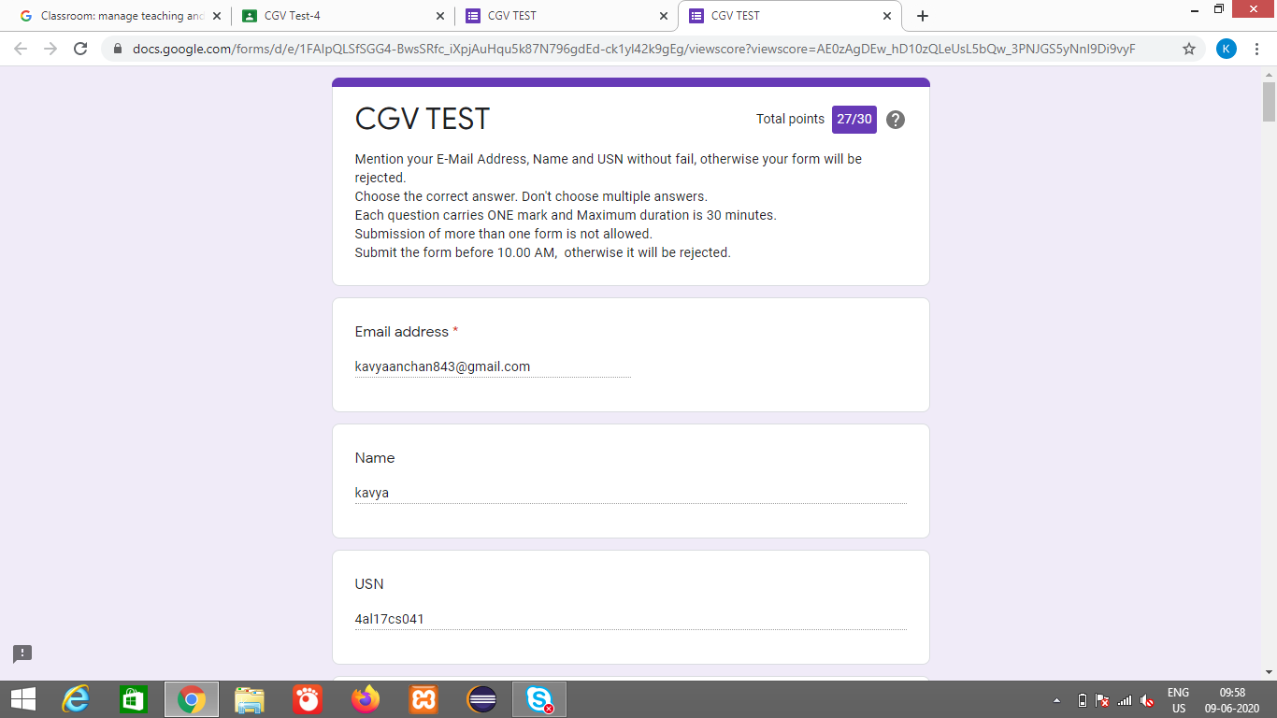

Certification Course Details: (Attach the snapshot and briefly write the report for the same)

**MATHS FOR DATA SCIENCE**

**What we’ll learn**

* Explore the application of key mathematical topics related to linear algebra with the Python programming language

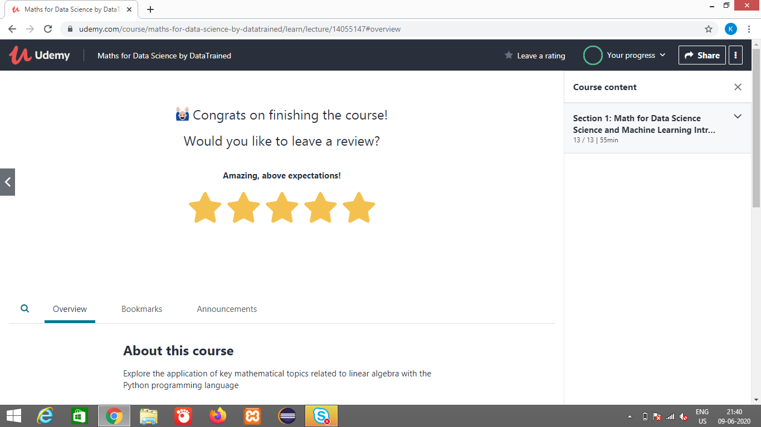

<https://github.com/alvas-education-foundation/kavya-onlinecourse>

Coding Challenges Details: (Attach the snapshot and briefly write the report for the same)

<https://github.com/alvas-education-foundation/kavya-OCA>